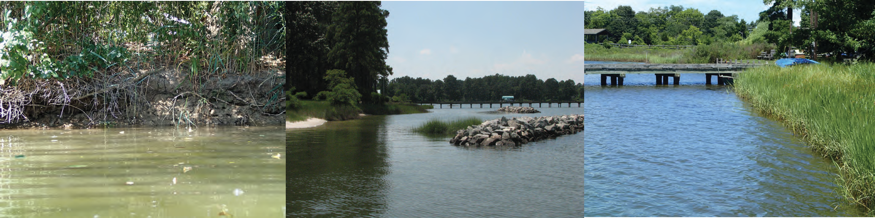
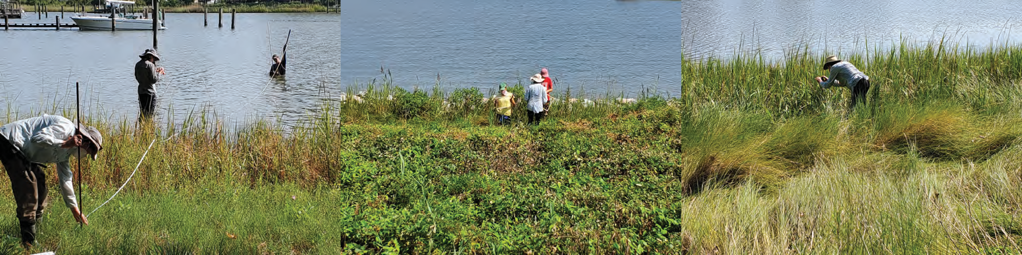
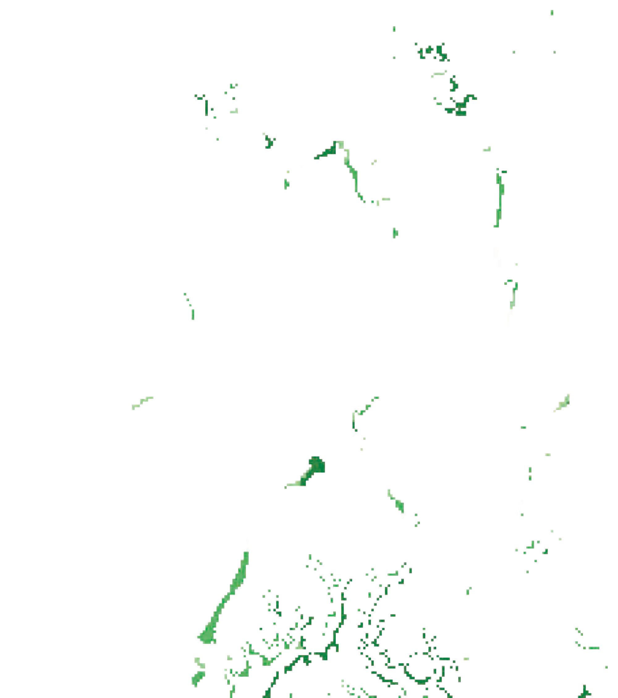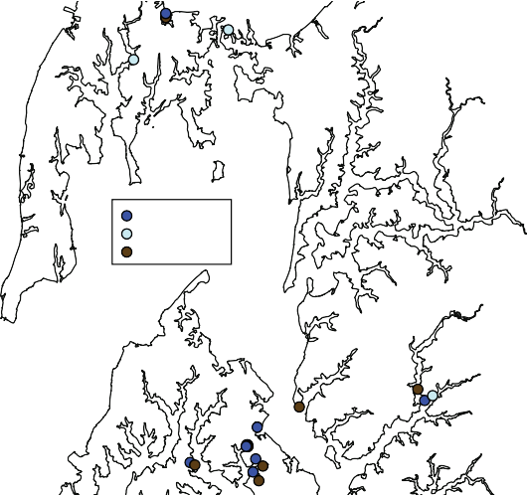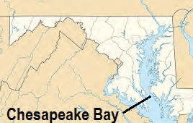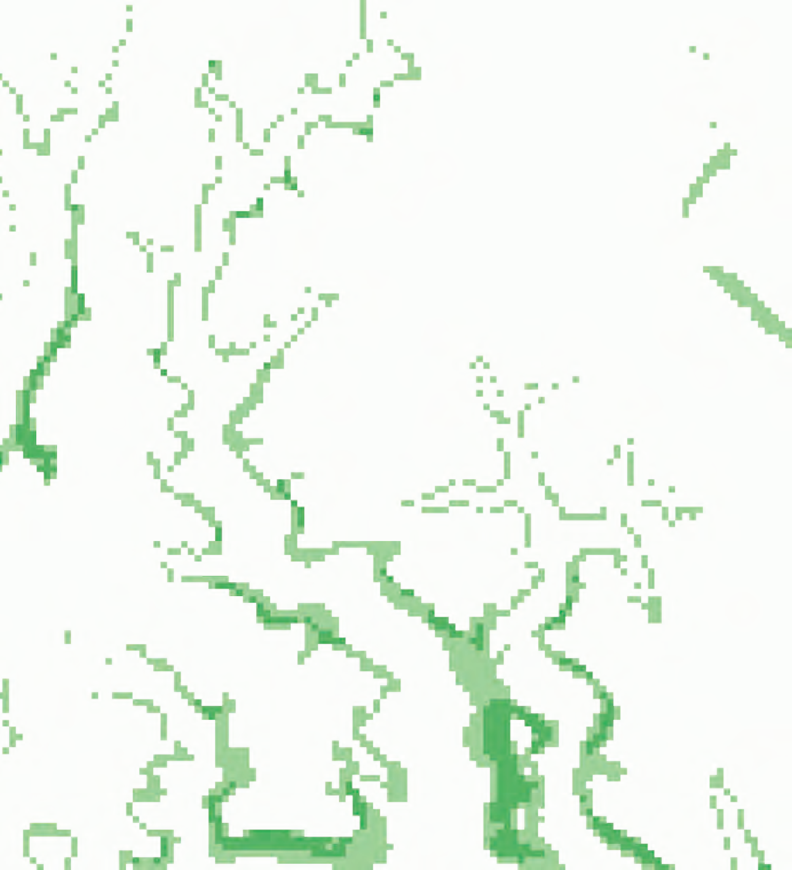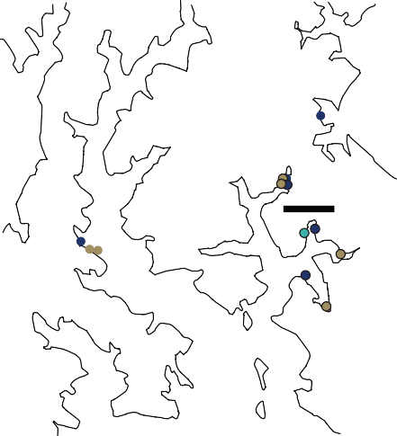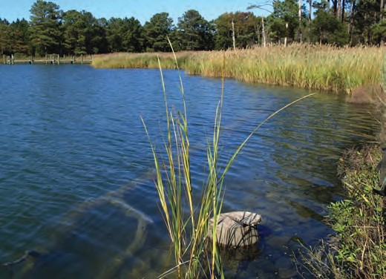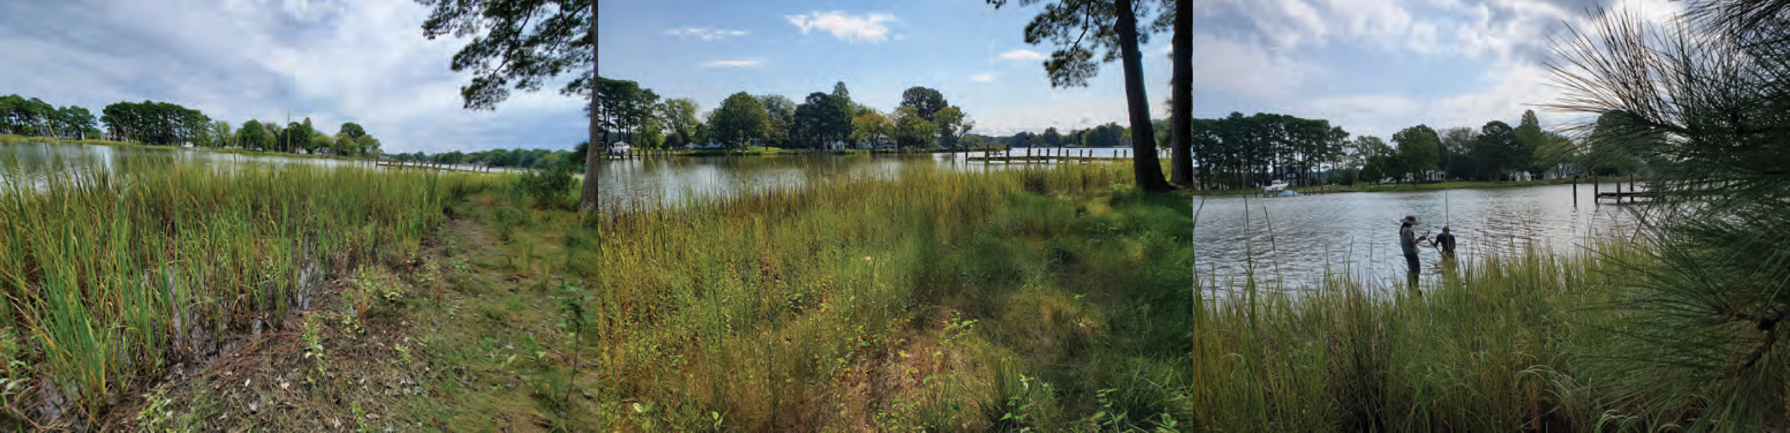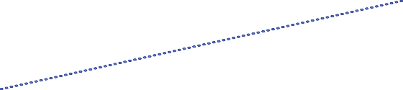Sediment-vegetation interactions in the created marshes of living shorelines: does age matter?
Study Sites in Chesapeake Bay
Weighted-bed density of 1978-2005 VIMS SAV data
- 8, ~10-year-old sites (dark blue) with paired controls (”natural”; brown)
- 4, 2-year-old sites (light blue) in close proximity; sampled for 3 years
Finan 2019 Finan 2020 Finan 2021
2 years old 3 years old 4 years old
HG 2018
10 years old
meters
0
750
~10 years old
~3 years old Natural
Stem density is similar in young and old living shorelines, on average, with high variability
2500

2000

1500

1000

500

0
As above, box plots of obervations at 4 young living shorelines (sampled in 2019 and 2020; accretion rates only in 2020) and corresponding 4 nearby older living shorelines (~10 years old at sampling)
High variability among sites obscures potential differences by age
Stem Density (/m )

2019
2 years

2020
3 years

Nearby
~10 years
Mud (maybe accretion rates?) varies with stem density
60
3.0
50
2.5
NA 2019 (2 years)
2020 (3 years) Nearby (~10 years)
40

30
r2 = 0.41
p = 0.01
(all data)
2.0

1.5
20
1.0
10
2019 (2 years)
2020 (3 years) Nearby (~10 years)
0.5
0
r2 = 0.78
p = 0.01
(w/out outlier)
0
500 1000 1500 2000
Stem density (/m2)
2500
0
0
500
1000 1500 2000
Stem density (/m2)
2500
Mud content (left)
Correlated with stem density across sites
Older living shorelines (dark brown) may have a different relationship?
We can add more data from our other projects and literature to help flesh this out

Accretion rates (right)
Without the outlier, good correlation between accretion rates and stem density Environmental context?
Not enough data to separate into young vs old, but we can add more data from other studies (ours and others)
So, does age matter?
For sediment trapping, sure seems like it!
Mud and accretion rates are higher at older living shorelines
For vegetation, not really?
Stem density trends are site-speci c
Plants are important!
Mud content (and maybe accretion rates) appear to be correlated with stem density, but statistics limited by number of sites
Coming soon…
Year 3 data! (in process now)
Biophysical drivers controlling sediment supply and stem density at individual sites
Overarching Research Questions (across multiple projects)
Do living shorelines:
Reduce shoreline erosion (performance)?

Impact submersed aquatic vegetation (SAV) benthic habitat and/or distributions in adjacent shallow waters (subtidal) (impacts)?

Increase net sediment/nutrient burial in the coastal zone (subtidal to intertidal)
(co-bene ts)?
THIS POSTER: (very) brief look at sediment grain size and accretion rates in
the created marshes of a few living shorelines
Compare young (~3 years old) and old (~10 years old) living shorelines Relationship to stem density
Mud content (%)
Accretion rate (g/cm2/y)
Shoreline erosion is increasing, and so are efforts to stabilize shorelines
- Chesapeake Bay (CB) focus but ubiquitous problem in estuaries and coastal embayments
•33% of CB’s shoreline is currently eroding; >70% of the Maryland portion
•85% of CB’s shoreline is privately owned

- Past efforts focused on “hard” approaches like rip rap and breakwaters
•25% of CB’s shoreline is already hardened, >50% in some subestuaries

- Recent push (including Maryland laws in 2003) for living shorelines as alternative
– but, how do they impact adjacent ecosystems, especially submerged aquatic vegetation (SAV)? and, what are the trade-offs in ecosystem services?
1 | 2 | 3


Cindy Palinkas*, Lorie Staver
University of Maryland Center for Environmental Science Horn Point Lab; Cambridge, MD
*cpalinkas@umces.edu; 410-221-8487
Mud content and accretion rates are higher at older living shorelines
Mud Content (%)
ab
b
50
40
a
2.5 Accretion
Rate (g/cm2/y)
2.0
1.5
30
Nearby
~10 years
20
1.0
p=0.06
10
0.5
2020
3 years
2019
2020
3 years
Nearby
~10 years
Letters: p<0.10
0
2 years
0
Box plots of observations at the 4 young living shorelines (sampled in 2019 and 2020; accretion rates only in 2020) and corresponding 4 nearby older living shorelines (~10 years old at sampling)
Increase in mud and accretion rates with age suggests that it takes many years for living shorelines to reach full trapping potential
Model young vs old differently and/or use different metrics for “success”?

